# Storage

*First create a html file*

And insert any subject in that html file

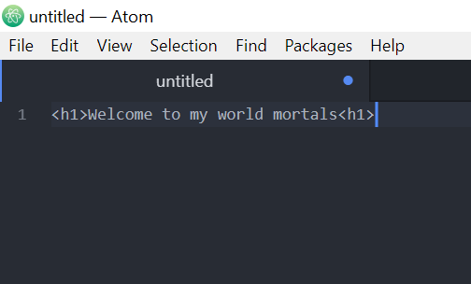

And then save it

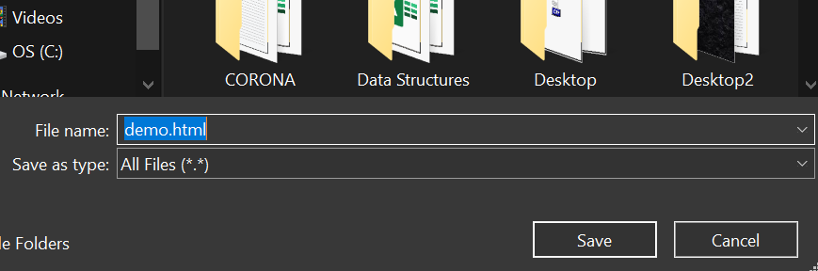

Name it demo.html

*Open AWS service*

And open the option Create a bucket

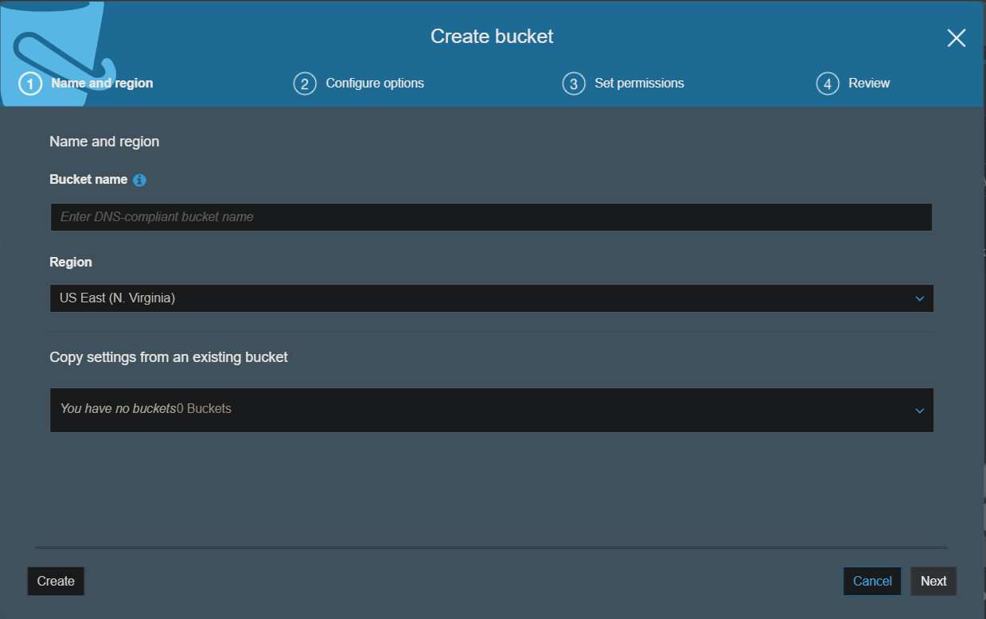

**Bucket name should always be unique.**

Create a bucket

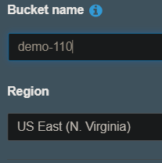

**Bucket will be created**

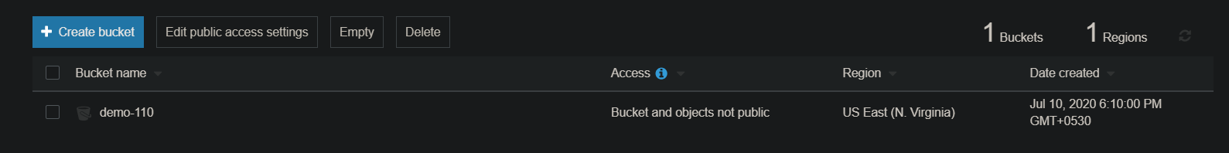

you can upload and download files in Buckets

POINTS TO BE REMEMBERED

if you upload a given file named demo and again upload a file with the same name the the file gets replaced.

After that create a folder named website in the bucket

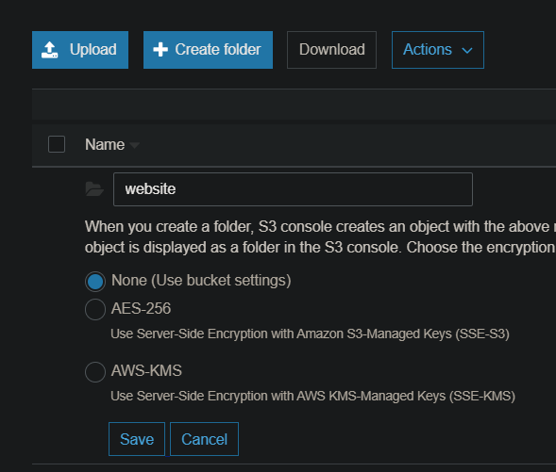

And go to the folder and upload the demo.html file

After that select the demo.html file and see the overview and you can see object url

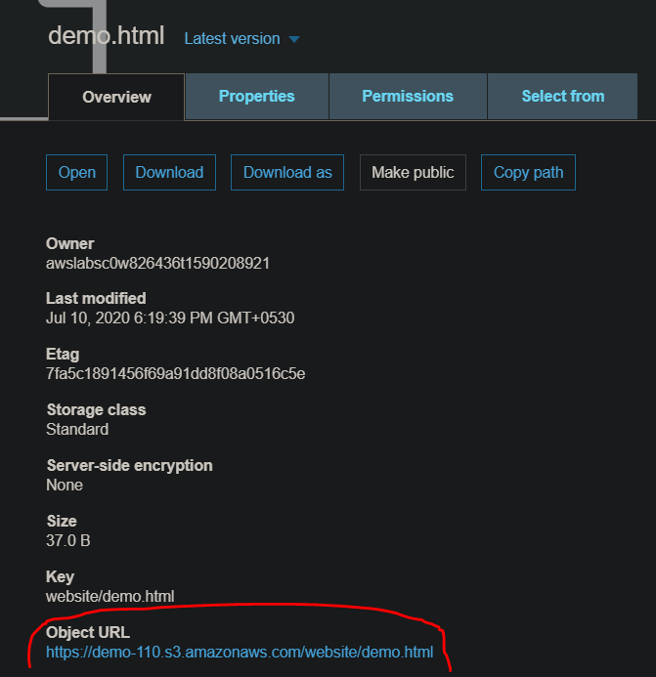

Click on that you will see something like this

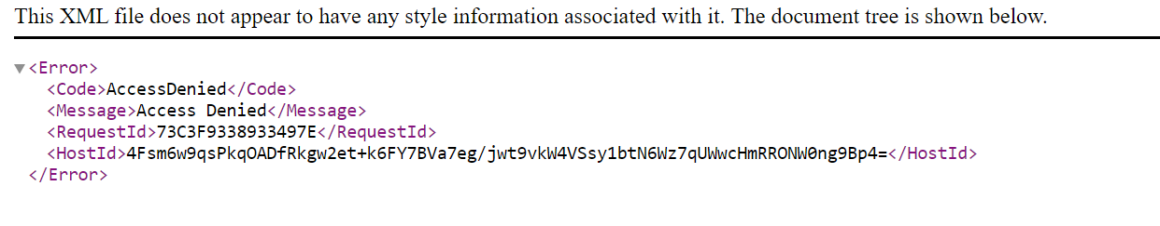

*By default anything you upload in private*

So the to make it public you have to make the Bucket in which your file is PUBLIC

To do that go to the folder select on Actions

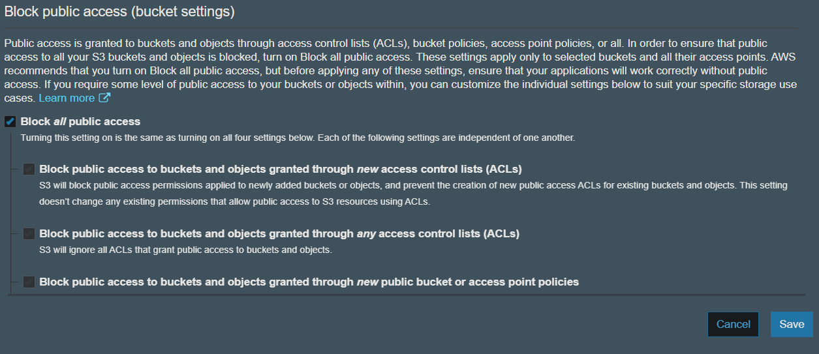

So unselect the public access block and save it.

Now you can select your demo.html file and make it public.

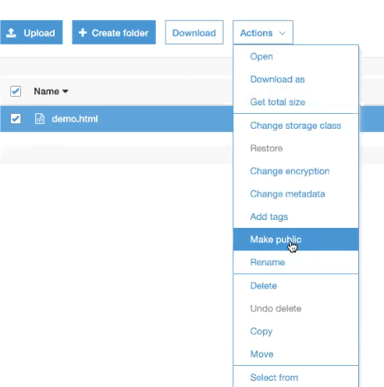

And go to the url and reload you will see

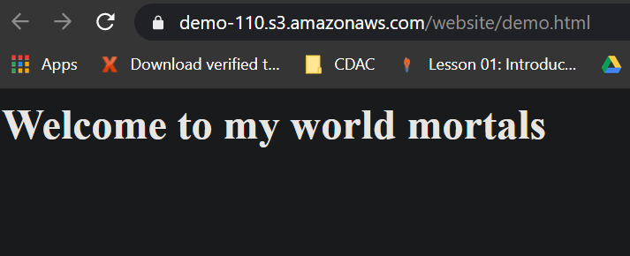

*Along with the html file you can also create css file*

Do it with same as html create an csv file and upload it on S3 in bucket named demo-110

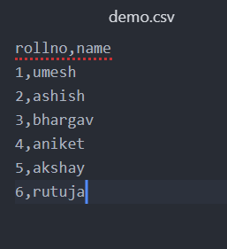

And upload it in the bucket in any folder you want

And after uploading select on that file demo.csv

You will see Select from Option

This and you can preview your file…this option is so powerful service in AWS where you can access and see the inner subjects of files.

You can also see zip files

You can even open an **SQL editor** to search for queries in S3 bucket databases

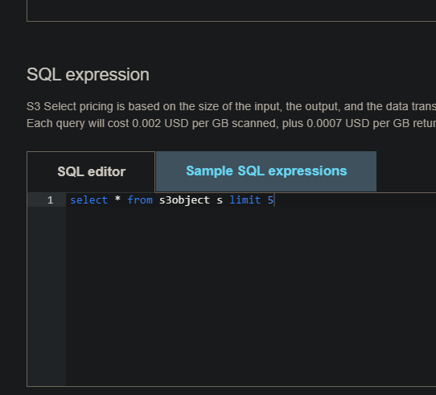

***BUCKET PROPERTIES***

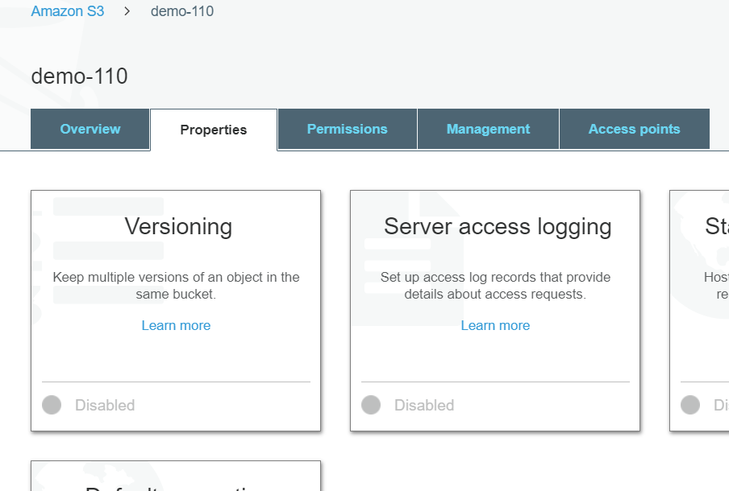

You can Go to Versioning option

And enable the option

What versioning does is it will show an option of every files with the same name you uploaded in the same folder

It will show versions of the files according to the period of time

*RDS*

Database as service

MANAGED RELATIONAL DATABASE SERVICE

MSQL , SQL service ,ORACLE

Cloud

* ***IASS – RAW computing (EC2)***
* ***SAAS—WInDOWS,TABLEU,SPLUNK,FS***
* ***PAAS—DEVELOPER FACING RDS***

Search for RDS in service

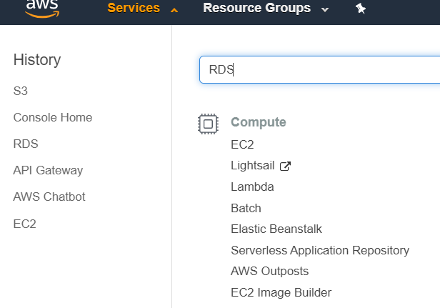

After that when you got to the RDS page go on left side DATABASES

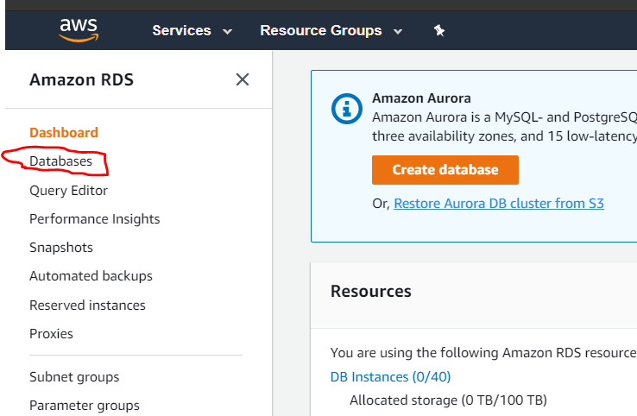

Click on it

And the click on create database on right side

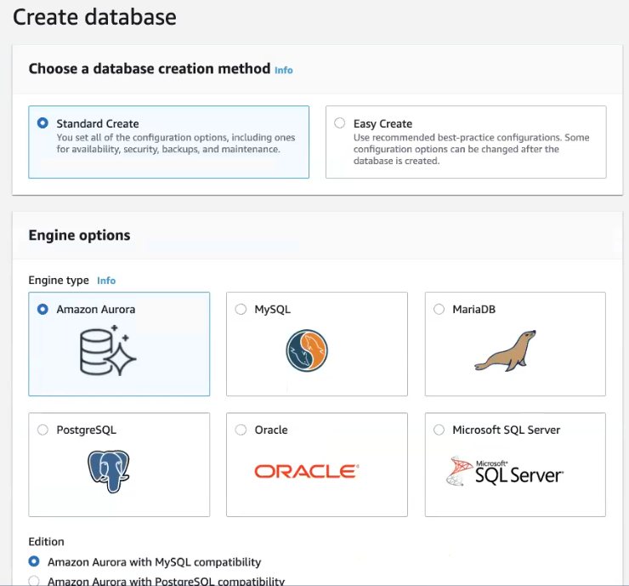

There are different **engine options** you can select

Select MYSQL and select the version

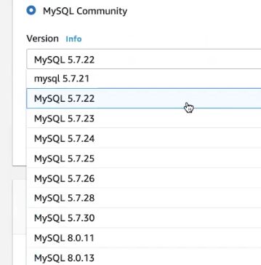

And then go to *templates* and select **free tier**

**And then name your database**

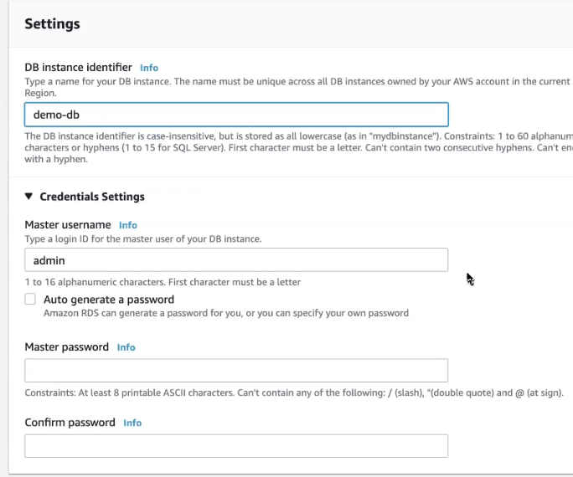

In free tier the instance size will be the minimum requirement

For connectivity make it public

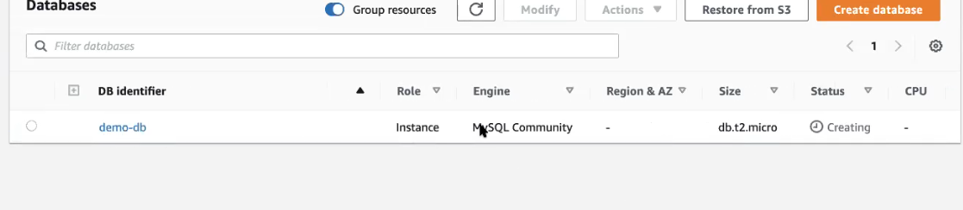

Your database is being created

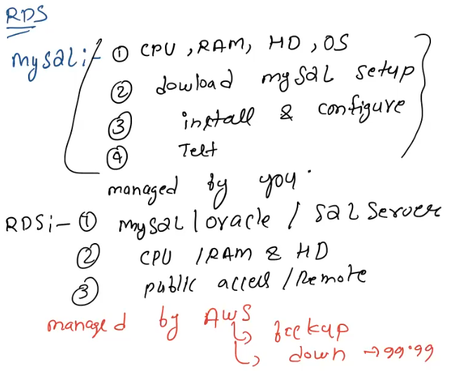

Information regarding RDS

Check your database file

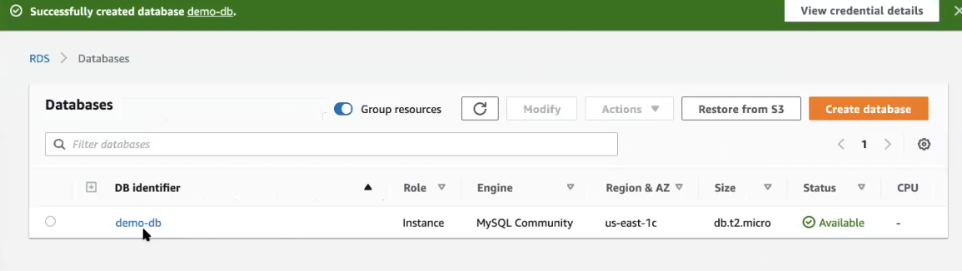

If you select your database

And got to

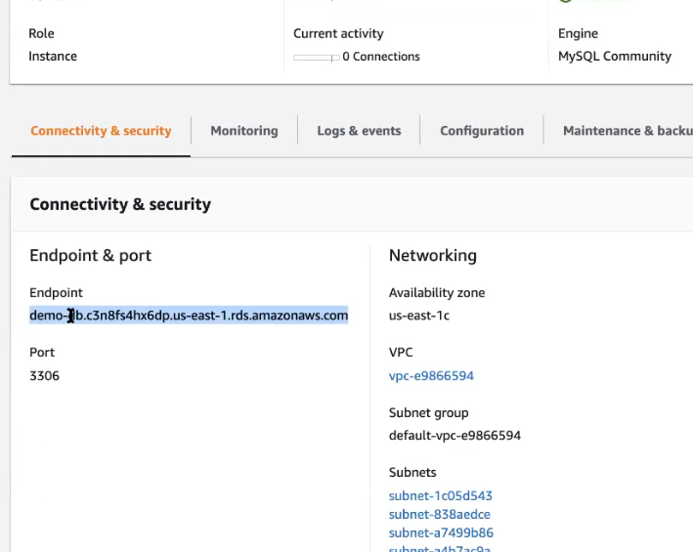

The selected text is you IP address

The go to security and you can access inbound and outbound rules

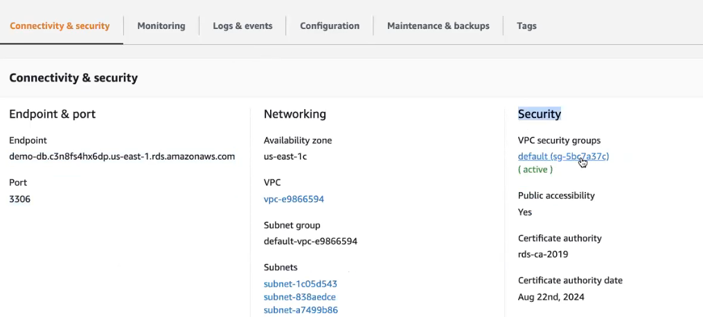

Goto inbound rules and add

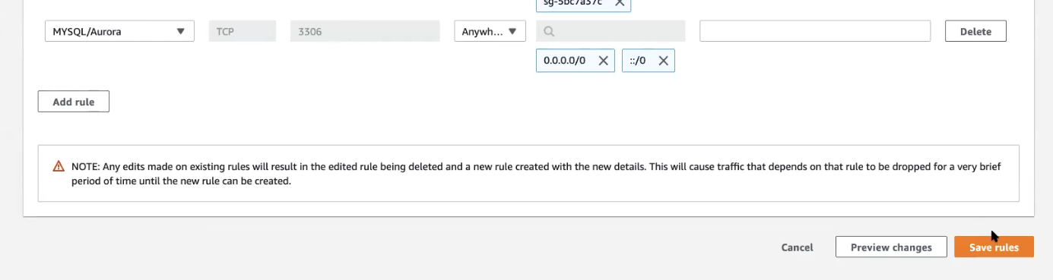

And now install ***SQL workbench***

In SQL workbench

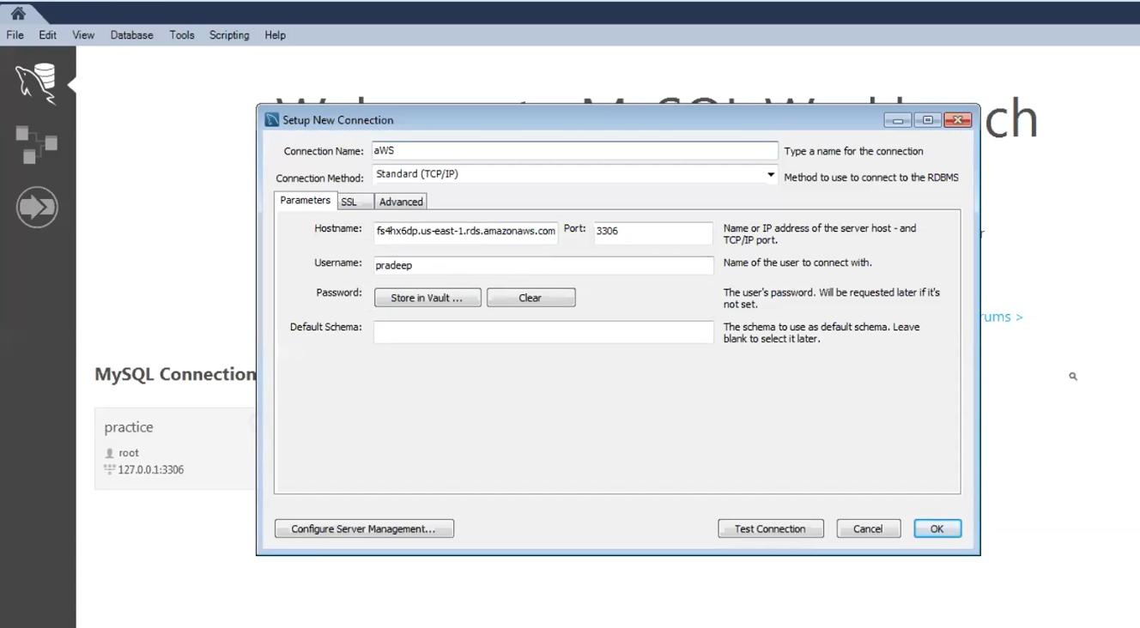

Form there you add create you databases.

Difference between EC2 and RDS

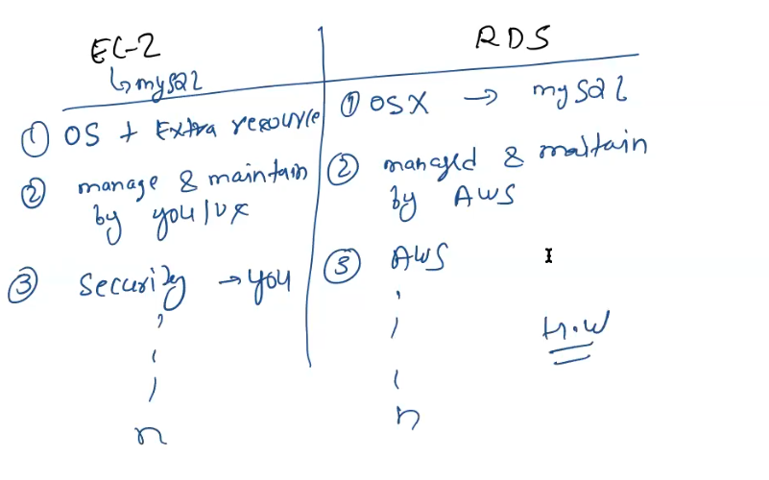

***SERVELESS COMPUTING***

**Serverless computing** is a cloud **computing** execution model in which the cloud provider runs the server, and dynamically manages the allocation of machine resources. Pricing is based on the actual amount of resources consumed by an application, rather than on pre-purchased units of capacity.

